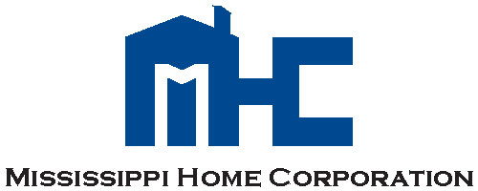

TO: All Local Units of Government, Project Administrators and Other Parties

FROM: Lillie Naylor

AVP Grants Management

DATE: July 2, 2019

SUBJECT: Notice of Funding Availability (NOFA)

2019 HOME Homeowner Rehabilitation/Reconstruction Phase I Application and Manual

Mississippi Home Corporation (MHC) hereby notifies all Local Unit of Governments, Project Administrators and other interested parties of the Notice of Funding Availability (NOFA) for the 2019 HOME Homeowner Rehabilitation/Reconstruction Phase I Application funding cycle.  Information pertaining to the NOFA along with the 2019 Application and Manual is located on MHC’s website at [www.mshomecorp.com/federal-programs/home/homeowner-rehab](http://www.mshomecorp.com/federal-programs/home/homeowner-rehab/).

Applications must be submitted by 4:00 p.m., Friday, August 16, 2019 to:

Mississippi Home Corporation

ATTN: Jackie Cobbins

735 Riverside Drive

Jackson, MS 39202

If you have any question and/or concerns, please contact Jackie Cobbins at 601-718-4635 or via email at [jackie.cobbins@mshc.com](mailto:jackie.cobbins@mshc.com).